**Data Analysis Report on User Adoption:**

**Executive Summary**:

The analysis was conducted on the 'takehome_users' dataset to identify factors influencing user adoption. The dataset includes basic information and engagement data of 8,823 users, among which **1,656 (or 18.76%) are adopted users**. The primary focus was to determine the key variables impacting user adoption and provide actionable insights.

**Key Findings:**

**1. Usage History:**

The length of usage history emerged as the most crucial factor influencing user adoption.

Users with a history >100 days were more likely to be adopted, and those with a history >200 days were always adopted users (Figure 2).

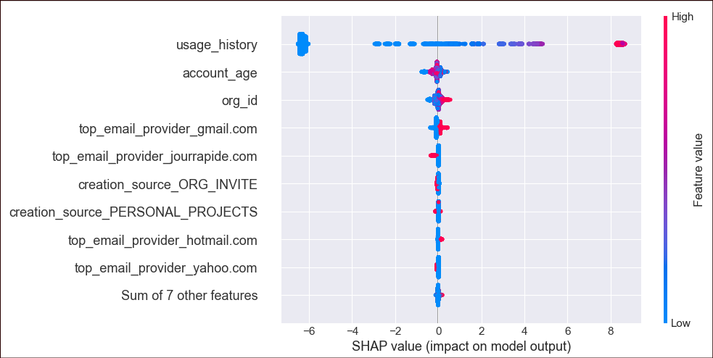

New users exhibited lower adoption rates, but no significant change was observed over the past two years.

**2. Source of Users:**

Users invited by other users and those signed up for personal projects had higher adoption rates.

Adoption rates based on the source of users are summarized in Table 1.

| Source | Adoption Rate |
| --- | --- |
| Guest Invite | 23.2% |
| Organization Invite | 18.0% |
| Personal Projects | 22.5% |
| Sign Up | 15.9% |
| Google Auth Sign Up | 17.3% |

**3. Email List and Marketing Drip:**

Opting in to the email list or marketing drip had no significant impact on user adoption.

**4. Predictive Model:**

Keeping in mind of a class imbalance, a Random Forest and an XGBoost model achieved >95% accuracy in predicting user adoption based on the dataset.

**Recommendations:**

Based on the findings, the following recommendations are proposed to enhance user adoption:

* Encourage existing users to log in and use the software after a certain duration.
* Promote user invitations and provide incentives for personal project engagement.

**Further Analysis:**

Exploring detailed user response data, such as responses to marketing moves, could provide insights into effective strategies.

More granular information about organizations can help identify target organizations for fostering adopted user growth.

**Conclusion:**

The analysis highlights the significance of usage history and the source of users in determining user adoption. Leveraging these insights, the organization can tailor strategies to encourage prolonged user engagement and capitalize on effective user acquisition sources.

**Note:** TakeHomeUsers_FeaturesInfo.xlsx : contains info about the Features, Feature Engineering, etc.